Grade 4 Food, our fuel 20.01.23
Science Worksheet

- Identify the food picture and write the food category.

1. 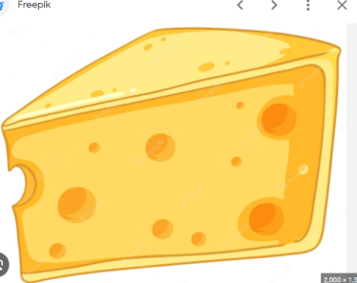 _________________

2. ___________________

3. 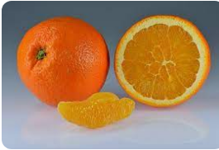 ________________
4. 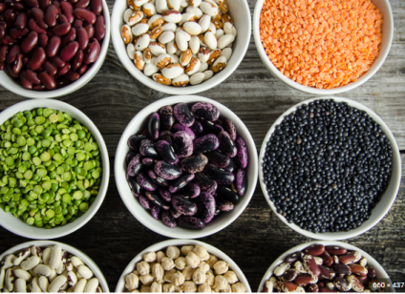 __________________
5. 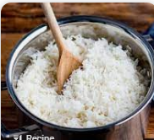 ___________________

II. Who am I?

- I am a very important macronutrient. I give energy to your body. I am the most important component of breakfast. Guess me. ___________
- I am present in carrot, mango and yellow vegetables. I am very useful for your eyesight. Who am I? _____________
- I am the important liquid. I help to absorb the nutrients. When I am taken less, you suffer from constipation. Guess me.___________
- I am the secondary source of energy in our body. I help to absorb the vitamins. Too much of me in your body leads to obesity. Who am I?______
- I am major component present in plant food, but I am not a nutrient. I help to digest the food. I am ___________.

III. Draw any two sources of the following.
- Plant protein
- Iron
- carbohydrates

